ERROR INTERVALS
Pearson Edexcel – Monday 8 June 2020 - Paper 3 (Calculator) Higher Tier
1.
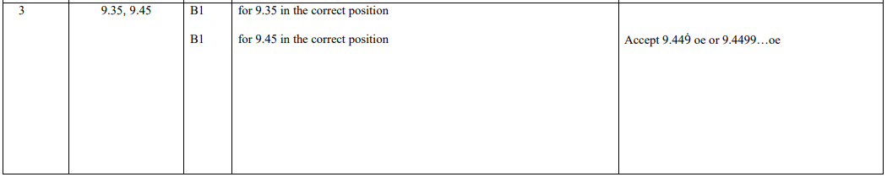
Pearson Edexcel - Thursday 6 June 2019 - Paper 2 (Calculator) Higher Tier
2.
Pearson Edexcel - Thursday 8 November 2018 - Paper 2 (Calculator) Higher Tier
3.
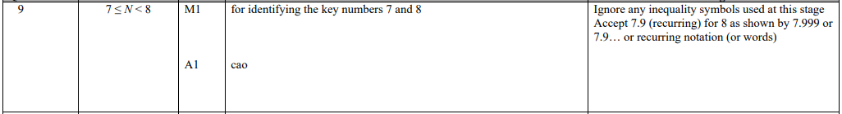
Pearson Edexcel - Wednesday 8 November 2017 - Paper 3 (Calculator) Higher Tier
4.
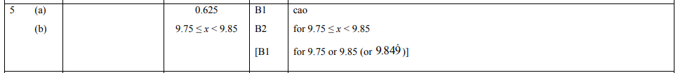
Pearson Edexcel - Thursday 8 June 2017 - Paper 2 (Calculator) Higher Tier
5.
Pearson Edexcel - Specimen Papers Set 2 - Paper 3 (Calculator) Higher Tier
6.
OCR GSCE – Tuesday 3 November 2020 – Paper 4 (Calculator) Higher Tier
7.
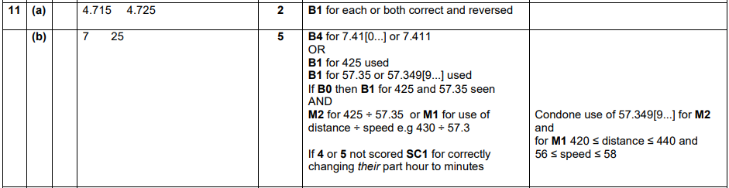
OCR GSCE – Tuesday 21 May 2019 – Paper 4 (Calculator) Higher Tier
8.
OCR GSCE – Tuesday 2 November 2017 – Paper 4 (Calculator) Higher Tier
9.
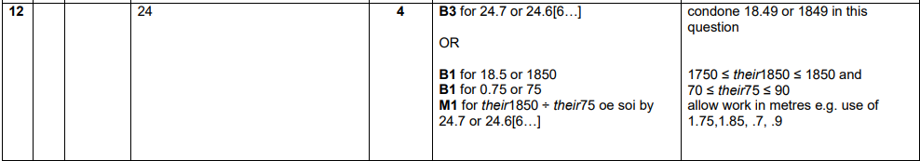
OCR GSCE – Thursday 25 May 2017 – Paper 4 (Calculator) Higher Tier
10.
OCR GSCE – Sample Papers – Paper 5 (Non - Calculator) Higher Tier
11.
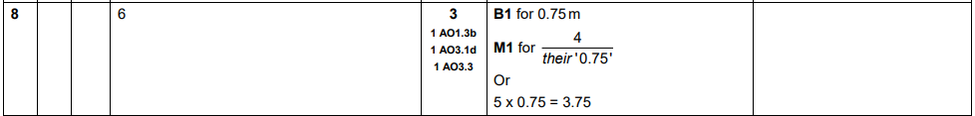
AQA GSCE – Thursday 8 June 2020 – Paper 3 (Calculator) Higher Tier
12.
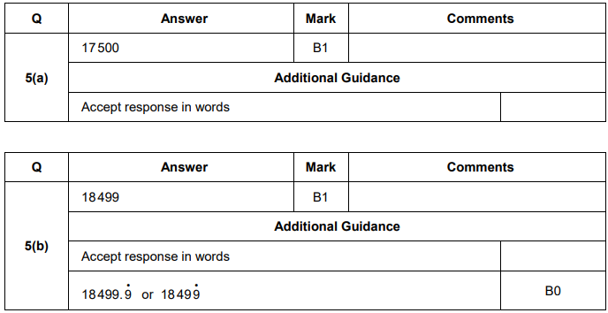
AQA GSCE – Thursday 6 June 2019 – Paper 2 (Calculator) Higher Tier
13.
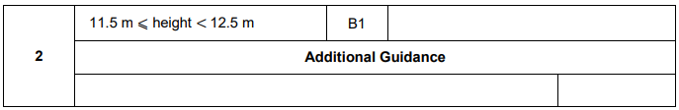
AQA GSCE – Thursday 6 June 2019 – Paper 2 (Calculator) Higher Tier
14.
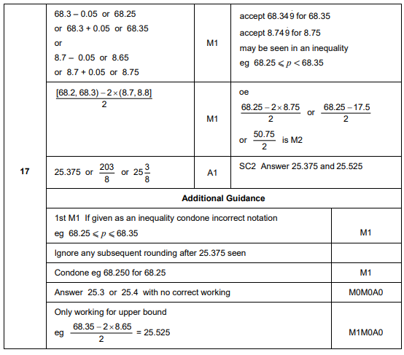
AQA GSCE – Monday 12 November 2018 – Paper 3 (Calculator) Higher Tier
15.
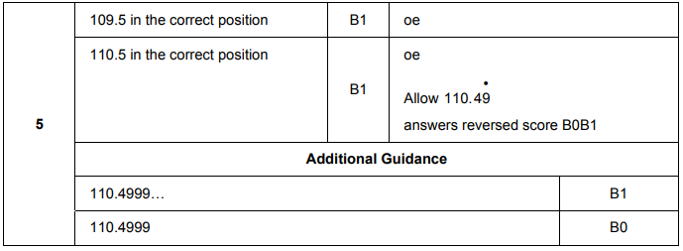

AQA GSCE – Thursday 7 June 2018 – Paper 2 (Calculator) Higher Tier
16.
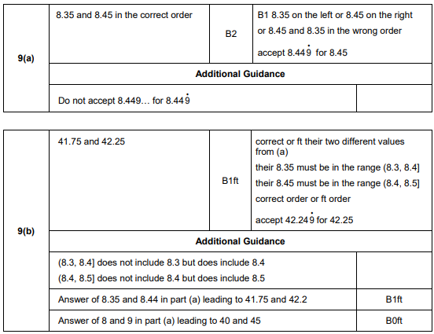
AQA GSCE – Tuesday 13 June 2017 – Paper 3 (Calculator) Higher Tier
17.
